# AMR HW 1

Mert Karakas – mmk2nh

## How to use

Each part of the Homework is separated with individual scripts. Running those scripts will produce the same graphs. The functions I’ve used are all in the “.zip” file.

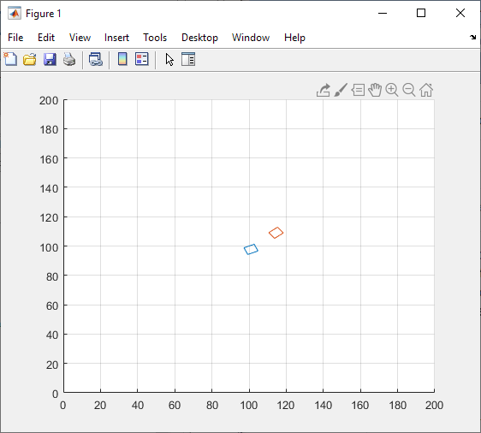

Initial pose

Part A

Part B

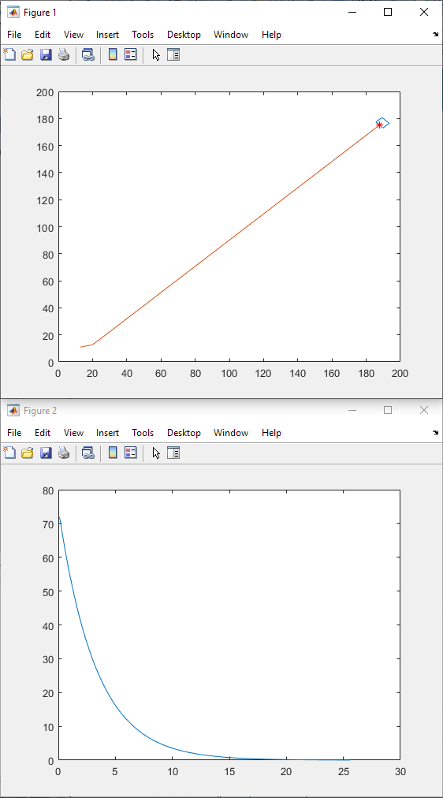

Velocity

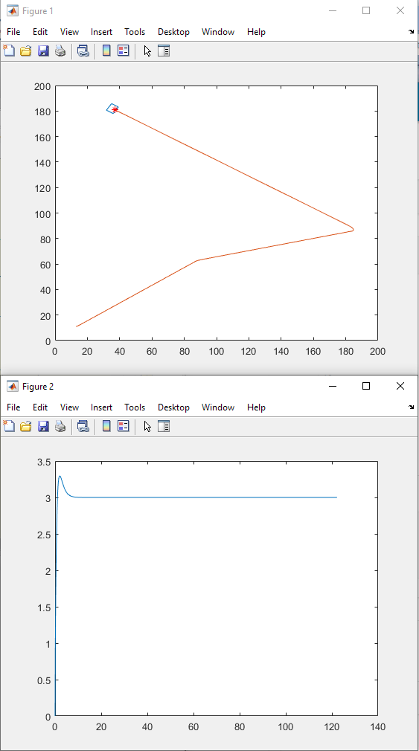

Part C

Velocity

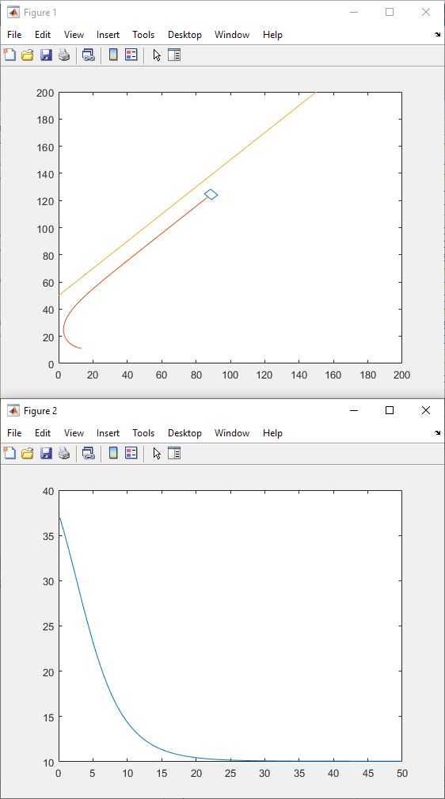

Part D

Distance from Line